|  |  |
| --- | --- |
| **Full Name** | **Ravi Kant Bharti** |
| **Batch** | **MS FSD DEC 2021 Cohort 1** |
| **Project Title** | **ICIN Bank** |
| **Project Submission Date** | **28/08/2022** |

**SIGNUP PAGE**

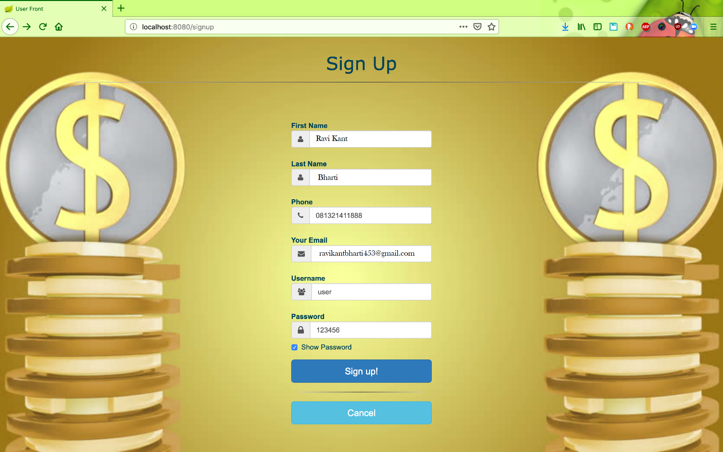

**LOGIN PAGE**

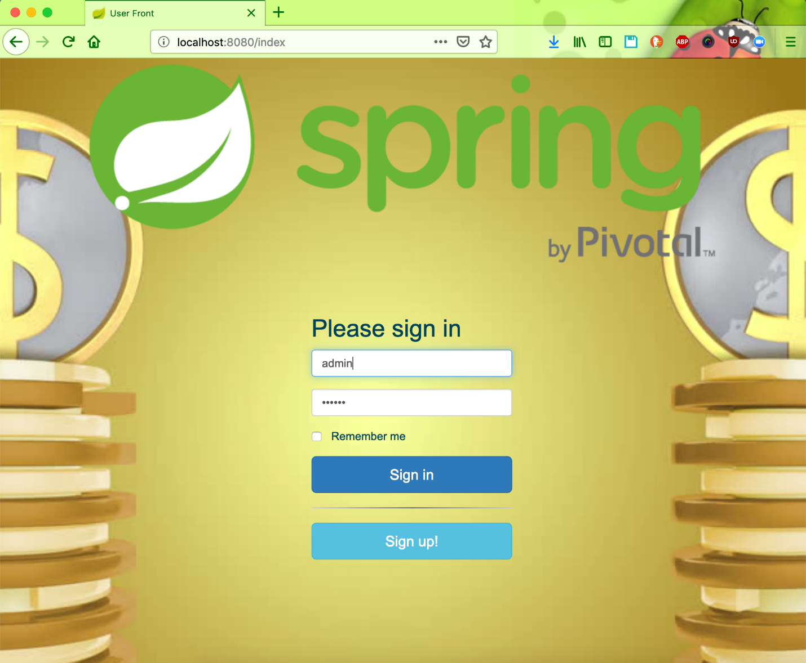

**DEPOSITE PAGE**

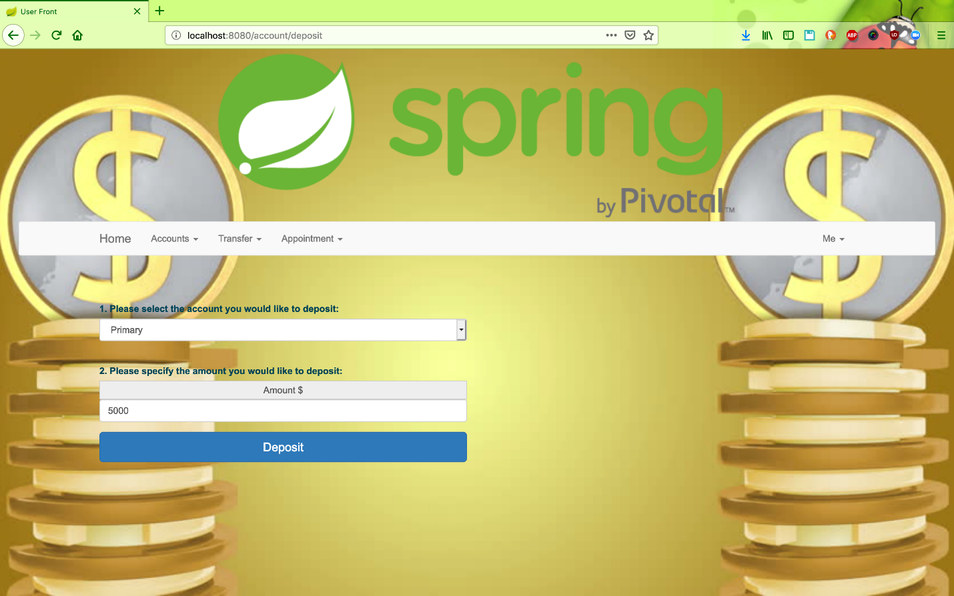

**DASHBOARD 1**

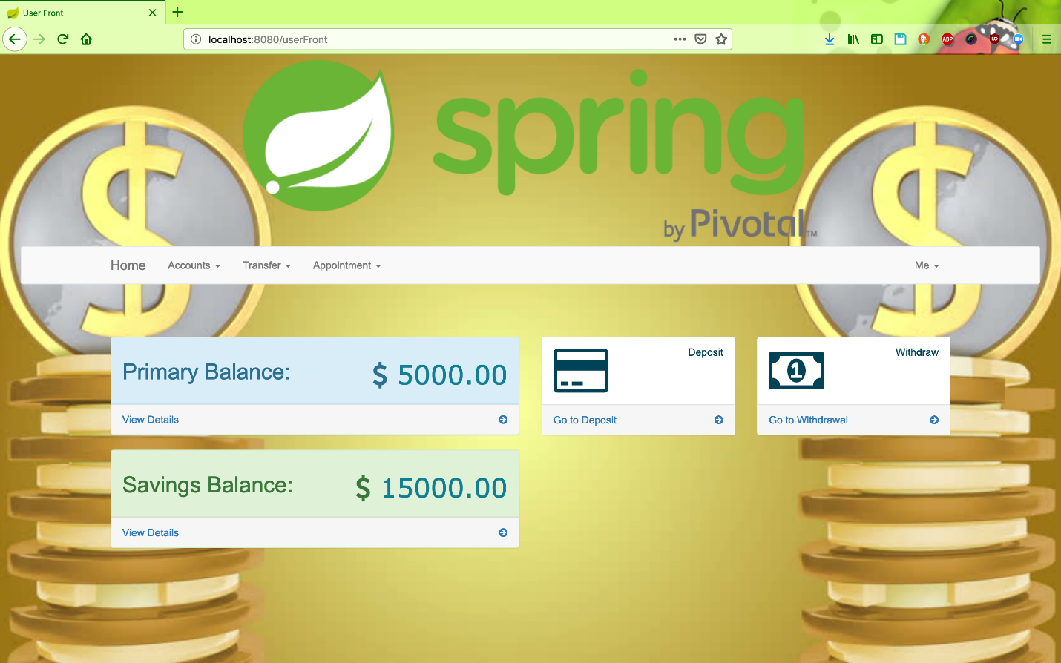

**DASHBOARD 2**

